Insert the paper title here [Franklin Gothic Demi Cond 26pt, left justified]

A.B. Author¹ and C.D. Co-Author² [Gill Sans MT 14pt, bold, left justified]
¹ Affiliation & address here [Californian FB 11pt, left justified]
² Other affiliation & address

Abstract [Franklin Gothic Demi Cond 26pt, left justified]
Please provide a brief (200 words max.), but informative abstract of the contents of the paper. The abstract should be created by overwriting the contents of this specially formatted table cell. This main body of the abstract uses the typeface Californian FB 9pt, with 1.15 line spacing, and is fully justified. Please provide up to three keywords. [Californian FB, 9pt, full justified]
Keywords: First Keyword, Second Keyword, Third Keyword. [Californian FB 9pt, italic, left justified]

1. Introduction
Manuscripts should not be more than six (6) pages in length following this two-column template. To assist the editing process, authors are strongly encouraged to prepare their manuscripts by overwriting this template directly.
The template is set for A4 paper with margins of 2.5 cm all round. The main body is set in two columns each of 7.6 cm in width and 0.8 cm spacing between columns.
This main body text should use the Californian FB 9pt typeface. It should be fully justified (i.e. on both left- and right-hand sides), and should have 1.15 line spacing, and zero spacing before and after paragraphs.
The opening of the first paragraph of any section or subsection, like the one above, should not be indented. The opening to second and subsequent paragraphs in a section or subsection, like this one, should be indented by 5 mm. A single hard return should be inserted between the end of one section and the heading of the next section.
References should be provided in a numbered list at the end of the manuscript. Citations of references within the body of the manuscript should be made using square brackets, e.g. [x].

2. First level headings
First level headings should be in Franklin Gothic Demi Cond 16pt, left justified. The heading should have a paragraph spacing of 3pt after. The headings should be numbered sequentially. The numbering should not be automatically generated, but should be typed manually and followed by a full stop and a single space before the typed heading.

2.1 Second level headings [Gill Sans MT 9pt, bold]
Second level headings should be in Gill Sans MT 9pt, bold, left justified. The heading should have a paragraph spacing of 3pt after. Second level headings should also be numbered sequentially, manually, with a single space between the number and the heading. Given the brevity of the papers, the use of third level headings is discouraged.

3. Tables, figures and equations
Precise details for the placement and formatting of figures is provided in Sections 3.2 and 3.3, respectively. Authors should ideally follow these instructions. However, the editors recognise that authors may not find this straightforward, and so the editors are happy for all tables and figures to be placed at the end of the manuscript (and the editors will arrange for the figures to be properly placed). Nonetheless the manuscript should still be no more than four pages in length.

3.1 Tables
Ideally tables should be sized to fit either fully across a single column (Table 1) or across the full width of the page (Table 2). Where absolutely necessary a table may be of an

Table 1: Table captions should be in single line spaced Californian FB 8pt with 3pt spacing after, and left justified.
 |  | Alloys Composition (wt.%)
 |  | Fe | C | V
Hypoeutectic | LA  HA | Bal.  Bal. | 3.0  2.8 | 4.6  4.7
Hypereutectic | LA  HA | Bal.  Bal. | 3.1  3.1 | 8.8  9.0

Table 2: This is a full page width table.
Alloy | Si | Cu | Mg | Mn | Zn | Fe | Al | Freezing range (°C) | Comments
Low  Average  High | 5  6  7 | 3  4  5 | 0.3  0.3  0.3 | 0.5  0.5  0.5 | 0.1  0.3  0.5 | 0.6  0.6  0.6 | Bal.  Bal.  Bal. | 508-617  505-607  500-596 | Lower limit of specification  Average composition  Upper limit of specification

Figure 1: This is a full page width figure. Figure captions should be in single line spaced Californian FB 8pt with 3pt paragraph spacing before, and left justified.

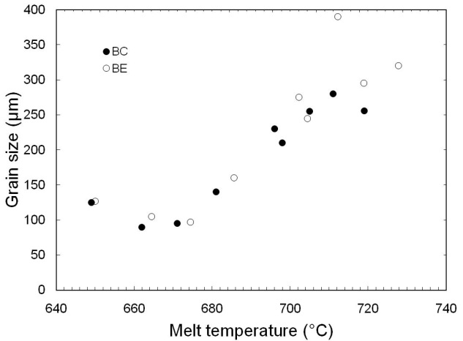
Figure 2: This is a single width figure.

intermediate width, but it must start at the left hand margin, and the main text should not wrap around it.
To keep tables visually clean, please limit the use of borders/lines between cells. For instance, in most cases vertical borders/lines are unnecessary. Where borders/lines are used they should have a width of ¼pt, except the top of the table which should be 1½pt.
Table captions should always be placed above the table. They should be of the form: Table x: Lorem ipsum dolor sit. The captions should be in Californian FB 8pt, with 1.15 line spacing, 3pt paragraph spacing after, and left justified.
Referring to tables in the main body of the text should always take the form Table x.
3.2 Figures
Ideally figures should be sized to fit either across the full width of the page (Figure 1) or fully across a single column (Figure 2). Where necessary a figure may be of an intermediate width (Figure 3), but it must start at the left hand margin, and the main text should not wrap around it. Each figure should be placed within a table cell, with ¼pt width borders, that fits to the column or page margins.
Figure captions for single column width or full page width figures should always be placed below the figure. They should be of the form: Figure y: Lorem ipsum dolor sit. The captions should be in Californian FB 8pt typeface, 1.15 line spacing, with 3pt paragraph spacing before, and left justified. The captions for figures of intermediate width should be placed to the right of the figure and the bottom of the caption should align with the bottom of the figure.
The proceedings will be produced in black & white. Therefore figures should ideally be provided in black & white. If figures are provided in colour then authors should ensure that they are easily interpreted when reproduced in monochrome, e.g. symbols representing data in graphs should be different shapes for different series. Authors should also take care that detail in colour photomicrographs is not lost when reproduced in black & white (contrasting colours can appear the same shade of grey when viewed in monochrome). All annotations placed on photomicrographs should be clear and readable.
Referring to figures in the main body of the text should always take the form Figure y.

Figure 3: This is a ¾ width figure. In this case the caption is placed on the right of the figure.

3.3 Equations
Equations should be centred and numbered sequentially in parentheses on the right hand side. This can be achieved by creating the equation inside a table thus:
(1)
Referring to equations in the main body of the text should always take the form Equation z.

4. Submission
Authors should ideally submit their manuscripts online at the SP27 website (www.sp27.org), using the account created at the abstract submission stage. However, should you wish to, you may submit your manuscript by email to Miss Susan Job at info@Sp27.org.
The deadline for submission of manuscripts is 1st April 2027.

Acknowledgements
Brief acknowledgements may be included. Note that the heading should not be numbered.

References
[References should be provided in a numbered list in the order in which they are cited in the body of the manuscript. The list should have single line spacing, with no space before or after, and should be fully justified (i.e. on both left- and right-hand sides). The style of references should be as follows]
- W.R. Wilcox, J. Crystal Growth, 1980, 48: 416.
- K.O. Yu et al., Trans. Amer. Foundrymens Soc., 1990, 53: 417.
- J.D. Zhu et al., Proc. 10th Internat. Symp. On Model. Cast. Weld. Adv. Solidification Processes, ed. D.M. Stefanescu, U.S.A., 2003, p.447.

